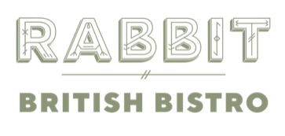

We use all things wild, foraged & locally grown, including sustainable livestock from the Gladwin’s family farm in Sussex & by-catch specials from nearby coastlines. We call this “Local & Wild”.
FARM TO FORK MENU
2 COURSES 24.0 | 3 COURSES 28.0
While you wait
Rabbit Wild Yeast Bread, House Butter | 4.5
Mushroom Marmite Éclair, Egg Confit | 4.0 (each)

BBQ Broccoli, Red Pepper Sauce, Pickled Cucumber
OR
Atlantic Coley Fishcake, Homemade Tartare Sauce

Newlyn Baby Monkfish, Tomato & Saffron Broth
OR
¼ Rotisserie Free Range Chicken, Green Salsa

Dark Chocolate Mousse, Salted Caramel

Add on:
Bistro Fries, Smoked Shallot Mayo| 6.5
Baby Lettuce & Preserved Vegetable Salad, House Dressing | 7.0

